Operational Concept Description (OCD)

WEB-Media Modernization 2012

Team 7

Anvar Bagiyev (Prototyper, Tester)
Xu Han (System Architect, Tester)
Barney Hsiao (Operational Concept Engineer, Tester)
Prayaas Jain (Feasibility Analyst, Tester)
Samantha Lüber (DEN) (Shaper, QPM, IIV&V, Tester)
Adam Smith (Project Manager, Tester)

October 31, 2012

Version History
Date | Author | Version | Changes made | Rationale
10/03/12 | Barney Hsiao | 1.0 | - Used original template provided from the ICSM EPG website and filled out relevant parts of the document. | - Document the team's goals and expectations with respect to the project.
10/12/12 | Barney Hsiao | 1.1 | - Fixed various formatting issues document from v1.0.  - Removed prompt text from each section of v1.0.  - Improved language and grammar.  - Changed blue text to black. | - Enhance readability.
10/24/12 | Barney Hsiao | 1.2 | - Updated sections 1.2, 2.2, 2.3, 3.1, 3.2, 3.3, 3.4. | - Preparing document for Foundations Commitment Review.  - Corrections from TA.
10/31/12 | Barney Hsiao | 1.3 | - Updated sections 1.2, 2.2, 2.3, 3.1, 3.2, 3.3, 3.4. | - Corrections after Architecture Review Board (ARB).
11/05/12 | Barney Hsiao | 1.4 | - Updated sections 2.1, 2.3, 3.1. | - More corrections after Architecture Review Board.  - Incorporate suggestions from TA and EPG.
11/26/12 | Barney Hsiao | 1.5 | - Updated sections 1.2, 2.1, 2.3, 3.3.1. | - Determined concrete5 CMS for ER diagram.  - Added Google Plus to System Boundary.  - Fixed semantic flaws of Benefits Chain.
12/10/12 | Barney Hsiao | 1.6 | - Updated section 2 | - Post TRR-ARB minor fixes.

Table of Contents

Operational Concept Description (OCD) i
Version History ii
Table of Tables iv
Table of Figures v
.......A.1 Introduction vi
.........A.1.1 Purpose of the OCD vi
.........A.1.2 Status of the OCD vi
.........A.2. Shared Vision vii
.........A.2.1 Benefits Chain viii
.........A.2.2 System Capability Description viii
.........A.2.3 System Boundary and Environment ix
.........A.3. System Transformation x
.........A.3.1 Information on Current System x
.........A.3.2 System Objectives, Constraints and Priorities xi
.........A.3.3 Proposed New Operational Concept xiv
.........A.3.4 Organizational and Operational Implications xv

Table of Tables

Table 1: The Program Model vii
Table 2: Relation to Current System xiii

Table of Figures

Figure 1: Benefits Chain Diagram viii
Figure 2: Element Relationship Diagram of CSC Website xiv
Figure 3: Business Workflow Diagram xv

.......A.1 Introduction

Purpose of the OCD
This document provides, in detail, the shared visions and goals of the stakeholders of the Chinatown Service Center (CSC) website. The Success-Critical-Stakeholders (SCSs) of this project are USC developers and stakeholders CSC. The list of USC developers is:
- Anvar Bagiyev (Prototyper, Tester)
- Xu Han (System Architect, Tester)
- Barney Hsiao (Operational Concept Engineer, Tester)
- Prayaas Jain (Feasibility Analyst, Tester)
- Samantha Lüber (DEN) (Shaper, QPM, IIV&V, Tester)
- Adam Smith (Project Manager, Tester)
Stakeholders of CSC are:
- Leonard Kwong, the client
- Board members / board of directors
- Health center collaboratives
- Health educators
- CSC Maintainers
- Users
- Funders / Investors
- Patients

Status of the OCD
- Modifications to Benefits Chain, System Boundary and Environment, and ER diagrams.
- Refined descriptions in system capability, capability goals, level of service goals, and organizational and operational transformations after interfacing with client.
- Organizational and Operational implications drawn based on current state of development.

Shared Vision
Table 1: The Program Model
Stakeholders  (Who is accountable for the initiatives) | Initiatives  (What to do to realize benefits) | Value Propositions  (Benefits i.e Why) | Beneficiaries  (Who derives value) | Assumptions
- All Beneficiaries  - USC Developers  - Board Members  - Health Center Collaborative  - CSC Maintainers | - Modernize website  - Marketing campaign to include website  - Add social-media features  - Change company workflow to accept traffic  - Re-instituting customer service  - Setting standards and guidelines for customer service  - Staff appropriately  - Adopting new federal health care standards quality measures  - Improving patient communications  - Surveying patients | - Drive more traffic  - Attract younger and newer crowd  - Better health care sooner  - Better quality of life  - Increase in government funding  - Attract different kinds of people to work and volunteer  - Attract more individual donors  - Patient to consider making the agency their Primary Patient Center Medical Home | - General users  - Funders / Investors  - Patients  - Donors  - Job seekers  - Volunteers  - Event organizers  - Service seekers | - Setting standards and guidelines will increase business image and attract funders / investors to the company  - Attracting younger crowds will increase company value and funding  - Improving patient communications will make patients consider CSC to be their primary health care provider  - Revamping website design / adding social-media will attract younger crowd  - Attracting younger crowd will bring more families to CSC  - Old clients will be able to adapt to transition of new site

Benefits Chain
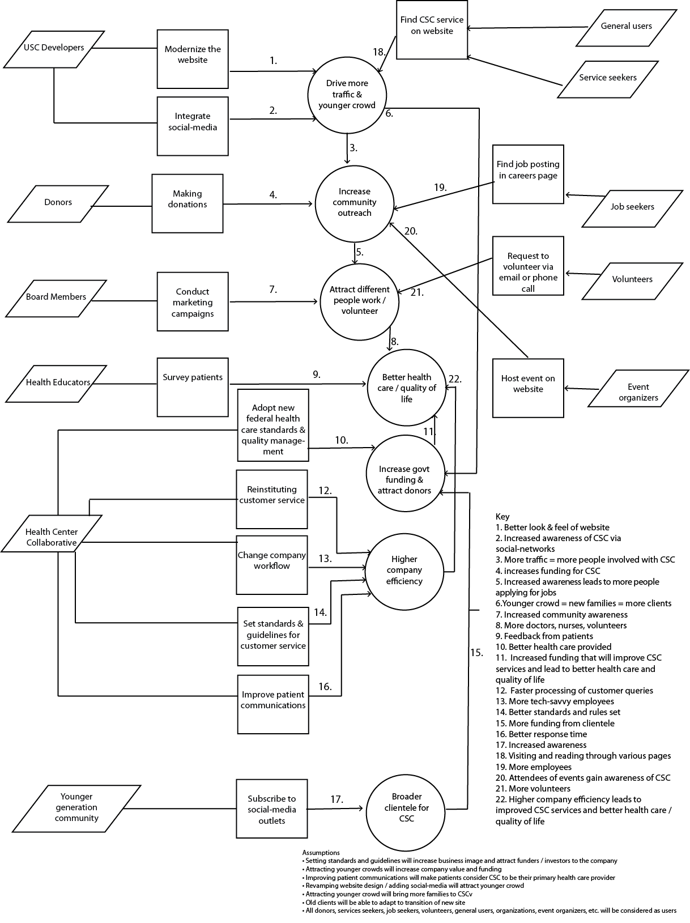
Figure 1: Benefits Chain Diagram

System Capability Description
- Expected benefits: bring good reputation and attract business to CSC.
- Type of system built: information website incorporated with social-media linkages.
- Target customers: a younger crowd seeking health and human services for themselves or their families.
- The need for to revamp the website: CSC board members find current website visually unappealing, which reflects poorly on the company’s image and discourages visitors from considering CSC services.
- Purpose of building the website: increase awareness of CSC and advertise their services to the community using multiple social-networks; allow visitors to better navigate the site and easily access relevant information.
- Little Tokyo Service Center (LTSC) is a partner of CSC and their website looks more professional than that of CSC.
- Primary differentiators to LTSC: add dynamic image sliders on the homepage, Google Calendar integration.

System Boundary and Environment
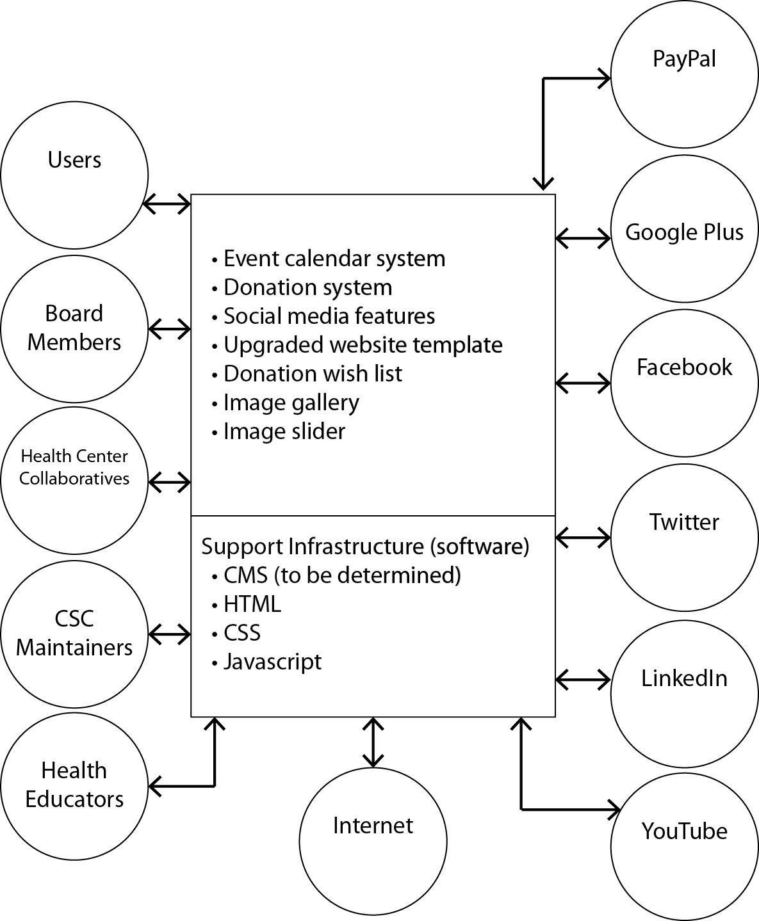

Figure 2: System Boundary and Environment Diagram for Proposed CSC Website

System Transformation

Information on Current System

Infrastructure
- Website content managed with CushyCMS.
- Website coded in HTML, JavaScript, PHP.
- Web hosted by GoDaddy.

Artifacts
The main artifacts of the website are:
- Social Media Update Item: gives updates about recent activities by CSC on a public forum (social media websites).
- Job Opening List: gives a list of the Jobs available with CSC.
- Event List: gives a list of the upcoming events for the next 90-120 days.
- Donation wish list: shows a list of the requests made by the various organizations/individuals.
- Image gallery: shows all images uploaded by CSC.
- Job Profile: gives a brief description of what a particular job entails.
- Job Application Form: sends information about the applicant to CSC.
- Event Profile: gives a brief description about an upcoming event.
- Event Image: an image uploaded by CSC for their most recent events.
- WishList Item: A particular request made by an organization/individual.

Current Business Workflow
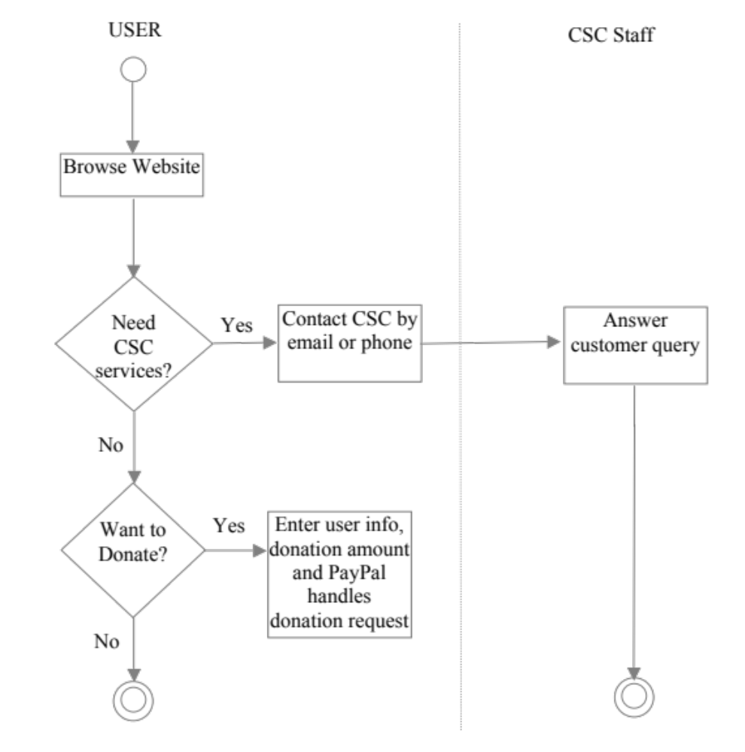

System Objectives, Constraints and Priorities

Capability Goals
Capability Goals | Priority Level
CG-1 Social-media integration | Must have
CG-2 Site management and upkeep | Must have
CG-3 Background template | Should have
CG-4 Wish list for donations | Should have
CG-5 Calendar event list | Could have

Level of Service Goals
Table 1: Level of Service Goals
Level of Service Goals | Priority Level
LOS-1: “Great” user experience:  “Great” in the sense that the all board members of CSC unanimously agree that the website design is professional, the layout is clean, and navigation of information is intuitive. The color schemes used for the website must be approved by the client and CSC staff. | Must have

Organizational Goals
OG-1: Drive more traffic to the website via social-media / social network advertising.
OG-2: Attract younger and newer crowd to CSC via the good impression made by a more professional and sophisticated website.

Constraints

CO-1: Testing time constraint: the functional website needs to be tested and feedback needs to be collected in time so that the development team can fix the errors/inconsistencies with the system.

Relation to Current System
Table 2: Relation to Current System
Capabilities | Current System | New System
Roles and Responsibilities | - Promote existence of CSC and its mission statement of reaching out to the underprivileged who require health and services. | - Promote existence CSC and its mission statement of reaching out to the underprivileged who require health and services.
User Interactions | - Users browse site to look for health and human services and resources. | - Users browse site to look for health and human services and resources.  - Use social-media buttons to share information to various social networks.  - Subscribe to CSC Google Calendar.
Infrastructure | - Website built using CushyCMS.  - Javascript, HTML, CSS, php. | - Website built using concrete5.  - Javascript, jQuery, HTML, CSS, php.
Stakeholder Essentials and Amenities | - Website provides information about CSC to seekers of health and human services. | - Website provides information about CSC to seekers of health and human services.  - Refined website design with enhanced navigation.  - Allows them to share this information on a social networking platform of their choosing.  - Embedded calendar showing upcoming CSC events.
Future Capabilities | - Social-media integration.  - New website template.  - Calendar event system. | - Search bar.  - Unified social network.  - Blog feature.

Proposed New Operational Concept

Element Relationship Diagram
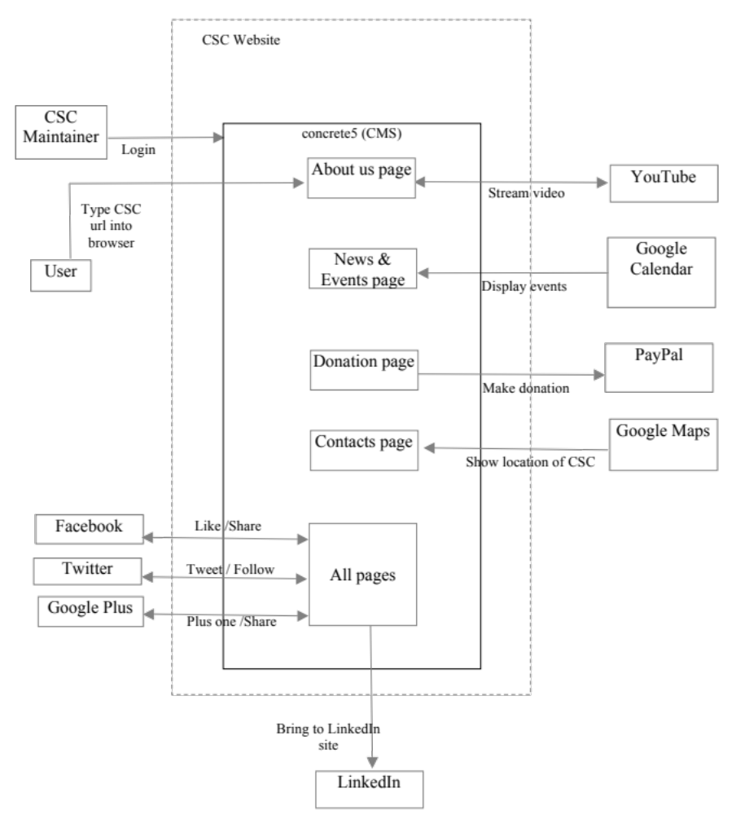
Figure 2: Element Relationship Diagram of CSC Website

Business Workflows
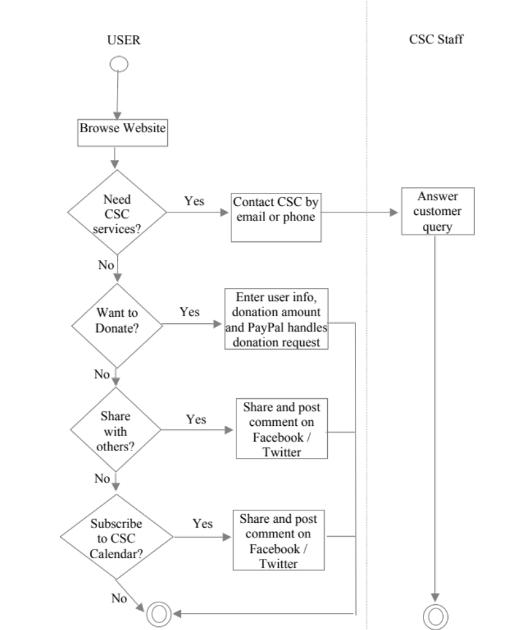
Figure 3: Business Workflow Diagram

Organizational and Operational Implications

Organizational Transformations
- The need to hire an events manager to populate and update events onto Google Calendar.
- Have the events manager maintain information, create and host events on various social networks including Facebook, Twitter, Linkedin, and Google Plus, also making sure information is in sync with the website.
- The need to train the current CSC website maintainers on how to use the new CMS in the event that the site is developed using a different Content Management System (CMS).
- Inform CSC staff, board members and clients about the replacement of the old website to the new one prior to website release.

………3.4.2 Operational Transformations
- Having the CSC maintainers keep information, including about us, events content and job applications, between Facebook, Twitter, Linkedin, Google Plus, Google Calendar, and the website all in synchrony.

